Comelan Molybdenum Monthly
June, 2015

Content:
1，General Review
2，Moly Oxide at Home and Abroad
3，Ferromoly at Home and Abroad
4，Moly Concentrate Transaction from Major Producing Areas (Comelan)
5，Ferromoly Tender from Major Steelmakers (Comelan)
6，Moly Chemical and Products
7，July Outlook

Comelan Molybdenum Monthly
June, 2015
1，General Review
The molybdenum market both at home and abroad gives negative reports in June, as the ended with a depressive grades. The major price also break the new record of historical low as the conflict of supply and demand is shape. As the European summer break approaching, the global demand will surely decrease, but the supply sees no sign of ease, which pushes down the global moly price first. As the international market falls, the import of moly oxide is made possible. With the ever falling price from ferromoly tender, mines are facing a painful dilemma.
The export tax on Chinese molybdenum is removed since May 1st, which boosts the export activity of the month. However, since the productive power at home is overwhelming, the export does little in alleviating the problem.
The molybdenum concentrate has experienced regular transaction early, and downstream buyers have made their regular purchases. However, in the mid-June, as the international market and the domestic ferromoly keep falling, the concentrate market basically pauses. As the pressure of inventory growing, most mines are willing to make sales, but with no deals done in the end.
The ferromoly market sees a greater rate of decline with 4000-5000 RMB/mt in a month. The volume of tender is the same but the price is going down.
Influenced by the upstream market, both the moly chemical and intensive processing markets have received negative impact, such as the ammonium molybdate and moly powder. The situation can be hardly called optimistic, and the concluding price is different.
2，Moly Oxide at Home and Abroad
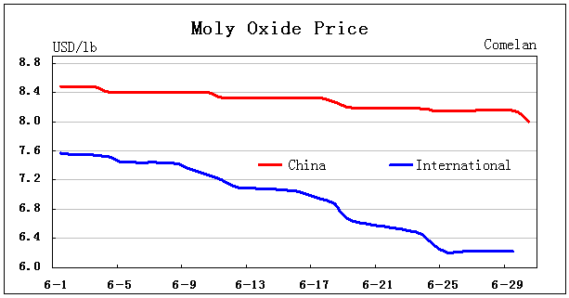
According to the figure above, the trend of the graph is down with the domestic price above the international price obviously. The gap is widened at the end of the month. The global price rises a little in the end, but the domestic trend is the not. Before the closure of the import gap, the domestic price can hardly sustain itself.
3，Ferromoly at Home and Abroad
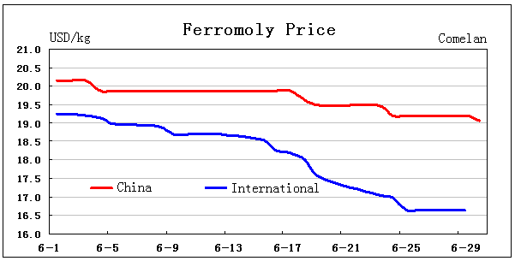
The market tendency of ferromoly at home and abroad is the same this month. According to the figure above, the global market is relatively stable before, but accelerates downward later, which creates a wider gap then. The global ferromoly price stops its acceleration in the end, but the gap is too small to actualize the import. However, the oversea influence is not over yet.
4，Moly Concentrate Transaction from Major Producing Areas (Comelan)
Major Producing Area | Volume | Price |  | Method and Note
Major Producing Area | ton | RMB/mtu | USD/lb | Method and Note
Inner Mongolia | 460 | 1000-1045 | 7.31-7.64 | Cash-Accepted
Northeast | 960 | 940-1060 | 6.87-7.75 | Cash-Accepted
Others | 280 | 950-1020 | 6.94-7.46 | Cash-Accepted
Total about 1700 ton, incomplete statistics!
Note:“RMB/mtu”/2.2046/10/exchange rate =“USD/lb”
Both the quantity and the price of the concentrate decrease month to month. After finishing previous orders, some mines take next orders via future goods with fewer in quantity, which pills up the inventory and eagerness.
According to our survey, concentrate conclusions mostly take place at northeast and inner Mongolia major producing areas. The fluctuation is big, especially the high grade concentrate. Low grade concentrate mostly concludes at south with low price.
5，Ferromoly Tender from Major Steelmakers (Comelan)
Date | Area | Volume | Price |  | Method
Date | Area | ton | 1000 RMB/mt | USD/kg | Note
6-2 | Shanghai | 630 | 72.5-73 | 19.47-19.61 | Accepted 3 months
6-2 | Jiangsu | 130 | 72.5 | 19.47 | Half Accepted (3 months)
6-3 | Shanxi | 350 | 72.7 | 19.53 | Accepted
6-3 | Zhejiang | 300 | 72.8 | 19.55 | Accepted
6-3 | Hebei | 50 | 76.5 | 20.55 | Accepted
6-3 | Shandong | 40 | 72.7 | 19.53 | Accepted
6-9 | Zhejiang | 50 | 72.5-73.5 | 19.47-19.74 | Accepted
6-9 | Guangdong | 40 | 76.48 | 20.54 | Accepted
6-9 | Jiangsu | 100 | 73.5 | 19.74 | Accepted
6-10 | Henan | 90 | 73 | 19.61 | Accepted
6-10 | Jiangsu | 130 | 72 | 19.34 | Half Accepted (3 months)
6-15 | Jiangsu | 320 | 73.25 | 19.67 | Accepted (+1000 tender fee)
6-16 | Tianjin | 170 | 71.85 | 19.30 | Accepted
6-17 | Liaoning | 70 | 71.3 | 19.15 | Accepted
6-18 | Jiangsu | 130 | 70.6 | 18.96 | Half Accepted（3 months）
6-19 | Shandong | 20 | 71.4 | 19.18 | Accepted
6-24 | Hebei | 60 | 72 | 19.34 | Accepted
6-24 | Jiangsu | 130 | 69 | 18.53 | Half Accepted (3 months)
6-25 | Jiangsu Hubei | 580 | 67.7 | 18.18 | Accepted
6-29 | Zhejiang | 300 | 67 | 18.00 | Accepted
Total about 3690 ton, incomplete statistics!
Note:”1000 RMB/mt”*1000/600/exchange rate =“USD/kg”
According to our incomplete statistics, the volume of ferromoly tender is basically the same month to month, but the price is going down. For example, a tender hold from Jiangsu is 72500 RMB/mt, half accepted 3 months at the beginning. The second week is 72000 RMB/mt, the third 70600 RMB/mt and the forth 69000 RMB/mt. This can show the tendency and rate of acceleration with no sign of the bottom.
6，Moly Chemical and Products
According to the major price of moly chemical and metallic products, we can see that the fluctuation is not big, as the production cycle is relatively long, especially the intensive processing market. Yet the general trend is still downward under the impact of the negative environment. With few positive factors, the market is handled with caution.
7，July Outlook
The domestic moly market did not jump out of the cycle of falling tender bids. Shaken by the shrinking global price, major domestic steelmakers intentionally lower the tender price, heating the competition of the molybdenum market.
The feature of early July is ferromoly tenders from major steel mills, especially steelmakers from Shanghai and Shanxi. Those from Jiangsu and Hunan might come in at the same time, with little change in quantity. The price might be around 66000 RMB/mt accepted.
Meanwhile, the concentrate market has attracted a lot of attention. The high grade concentrate is below 950 RMB/mt accepted with a big fall. As most mines are so eager to sell, the price is approaching the level of 900 RMB/mt accepted.
As the end-user demand is weak, and the supply of concentrate is big, plus the import of moly oxide is taking place, the moly mines are under heavy attacks. There is great possibility that some are going to reduce the output, or even stop the production. The price of concentrate breaking 900 RMB/mtu is also possible.

Note: The production data is from National Bureau of Statistics, the import and export data is from the General Administration of Customs, the rest is from Comelan. All opinion is private for reference only.

