Comelan First Semiannual Report, 2015
Overview:
The domestic molybdenum market of the first half year of 2015 can be summarized as price of ever dropping. The fallen price has broken the historical low as the underperformance of the domestic iron and steel industry weakens the end-user demand. The molybdenum market is under heavy pressure without enough support. The domestic market in May has attracted attention worldwide as the export tax on molybdenum products is cancelled and the resource tax has undergone reformation. Influenced by the fallen price of the international market, the import to the Chinese market has taken place in June, pushing down the domestic price forcibly. All in all, the Chinese molybdenum industry is facing new challenge at the end of the first half year.
Content:
I、Molybdenum Price Trend
- Domestic Concentrate
- Domestic Ferromoly
- International Molybdenum
II、Ferromoly Tender at Home
III、Import and Export
- Import
- Export
IV、Outlook

I、Molybdenum Price Trend

1，Domestic Concentrate

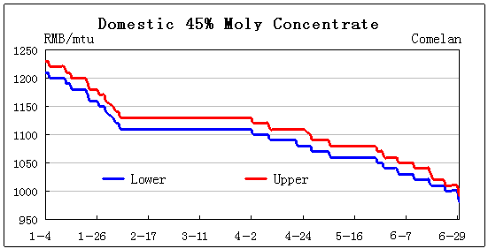

According to the figure above, the molybdenum concentrate price shows downward trend generally. The 45% concentrate price falls from 1210-1230 RMB/mtu to 980-990 RMB/mtu. Influenced by the international market and weak demand of steel market, concentrate is dealing at a very slow pace which spreads negative sentiment to the market.

After the New Year holiday, the price of concentrate continues the downward trend from last year. This is because many firms are facing heavy financial pressure then with obstacles like weak demand. Few firms are ready to make a sale as most of them are preparing for the Chinese New Year. The molybdenum market is hibernating.

After the Chinese New Year, due to the slow recovery of the economy, many industries postpone their projects, including the iron and steel industry. The molybdenum market has entered a hard time with few activities. The concentrate price stabilizes around 11100-1130 RMB/mtu for a relative long time before going down in April. The price goes downstairs with ferromoly market.

The export tax of molybdenum product from China is officially cancelled since May 1st, and the resource tax on mining is changed from quantity based to price based. Molybdenum related stock all hit the upper daily limit as the policy announced, leaving the real economy in the stalemate. However, the peace is short as the price continues downstairs at the end of May. Some mines make low price sales to alleviate the cash shortage. The demand from steel mills and the intention of deliver is further out of balance.

The fluctuation is great in June. As the decline of the international market accelerates, the import of moly oxide to China is actualized. Domestic mines are greatly challenged that some remark it with “life and death”. The mainstream price is at 980-990 RMB/mtu, and few inquiries and deals are heard.

2，Domestic Ferromoly

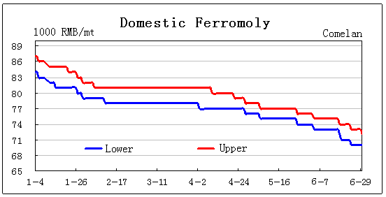

The price of ferromoly is the same as that of concentrate, which rise never takes place. According to our survey, some small and medium ferromoly factories have to reduce their output or even pause to meet the environmental requirement. Ferromoly factories are in a tough situation.

According to the figure above, the mainstream price of ferromoly is at 84-87 thousand RMB/mt at the beginning of the 2015. Before the Chinese New Year, or the mid-February, the price continues the downward trend to 78-81 thousand RMB/mt. The ferromoly stays with the concentrate for a while in April then.

Pressured by tenders from steel mills, the ferromoly take the lead in decline The mainstream price is at 70-72 thousand RMB/mt in June 30th. Influenced by international moly oxide, the ferromoly meets no resistance along the course of decline, breaking the level of 70 thousand RMB/mt is for sure.

3，International Molybdenum

According to the figure, the international molybdenum market generally goes down in the first half year of 2015. The molybdenum oxide price falls from the highest $9.4/lb to the current $6.2/lb, and European ferromoly falls from the highest $23.5/kg to the current $16.15/lb with the rate of 30%. The main reason is slow recovery of global economy and weak demand from manufacture industry. Market is not surprise with the tendency, but suffers panic after all.

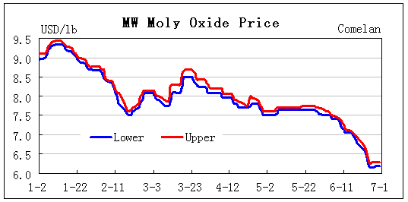
The mainstream price of international molybdenum oxide is about $9/lb after Chinese New Year festival. The price is stable though with less activity. Then, after reaching $9.5/lb high, the moly oxide starts to fall with fluctuation along the way.
The price reaches $7.7/lb in the mid-February. The market sentiment is calm with hesitation shown by sellers. Then, to their surprise, the market rebounds to $8.7/lb in the mid-March, which pleases all participants. However, little conclusion is closed there. Influenced by oversupply, the moly oxide goes down again to $7.5/lb in May.
The Chinese market attracts worldwide attention in May as the export tax on domestic products is officially cancelled and resource tax has undergone reformation. The Molybdenum Industrial Summit Forum takes place at Luoyang from 18th-20th, too. However, all of these have done little to help the market.
The moly oxide reaches $6.2/lb at the end of June, heading toward $6/lb then. As the international price is lower than the domestic price, some Chinese firms are importing oversea products, which stabilizes, or even push up the global market for a while. Yet, this might be a temporary peace as there is little support at the moment.

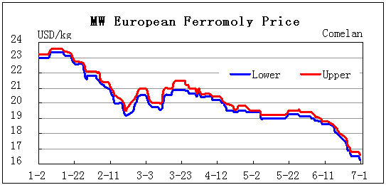

European ferromoly is similar to the moly oxide. The price climbs from $23/kg to $23.6/kg, then comes off to $19.2/kg in the mid-February. After that, the price bounces back to $21/kg, but stays low later. The ferromoly assessment hangs around there for a while at the early May, then goes down to $16.2/kg at the end of June. The main cause is still the weak demand from steelmakers.
During this period, there are news such as production halts of global giants and bankruptcy of Molycrop. But the export tax cancellation of China in May 1st does shake the market worldwide, as everyone fears further competition terribly. After a short period of observation, the market only finds out that the new policy does little practically. Many international giants increase their output for their self-preservation. Sierra Gorda of Chile is now operating, and Mt Hope project of General Moly has won support from AMER Group. The oversupply has no reversion, but further intensified. The market sentiment starts panicking, sellers change from bargain to desperate offering.

II、Ferromoly Tender at Home

According to Comelan statistics, quantity of ferromoly tender of major steel mills in China decreases year on year. In the first half year, the volume has decreased about 3740 ton. Top ten steel mills at home has taken 1600 ton less than before, which accounts to the 50% of the volume decreased in the whole market.

Major Ferromoly Tender of the First Half Year,
2013-2015 (Unit:ton)
Year | 2013 |  | 2014 |  | 2015
Month | Mean | Quantity | Mean | Quantity | Mean | Quantity
January | 12.365 | 6675 | 9.9 | 2720 | 8.32 | 4940
February | 12.11 | 2740 | 9.79 | 1550 | 7.98 | 2650
March | 11.07 | 4720 | 9.37 | 5630 | 7.95 | 4875
April | 10.6 | 5995 | 9.41 | 6820 | 7.84 | 3610
May | 10.445 | 7585 | 9.8 | 6390 | 7.59 | 3760
June | 10.115 | 5335 | 9.87 | 4206 | 7.335 | 3740
Total | 11.12 | 33050 | 9.69 | 27316 | 7.84 | 23575
Incomplete Statistics by Comelan

According to the data above, major steel mills at home has made less purchase in quantity during the first half of 2015, which is about 13.7% comparatively.

Data of Major Ferromoly Tender,
2012-2015 (Comelan Unit:ton)
Steel Mill | 2012 | 2013 | 2014 | 2015
Baosteel | 2620 | 4120 | 3850 | 3990
TISCO | 4850 | 3800 | 3300 | 3150
CITIC Pacific | 3200 | 3700 | 3480 | 3200
HBIS | 1230 | 1690 | 1190 | 1040
TPCO | 2250 | 1950 | 2590 | 1610
ZPSS | 1150 | 1780 | 1810 | 2560
ZSESS | 700 | 1350 | 2360 | 1650
LISCO | 2160 | 2500 | 1166 | 335
NJSTEEL | 650 | 1330 | 1240 | 1180
HYST | 420 | 680 | 470 | 1120
Total | 19230 | 22900 | 21456 | 19835
Incomplete Statistics!

Comparing to the quantity of tenders of top ten steel mills in recent years, though some steel mills increase their volume, such as ZPSS, HYST, etc, there are many steel mills who decrease their purchase, such as LISCO. Therefore, the total quantity is almost the same.

III、Import and Export
During the first half year of 2015, both the import and export volume decrease sharply year on year. According to the statistics from national customs, the import of molybdenum products is about 5033467 kg in total, about 40.27% less year on year. The export is about 5646026 kg, 44.12% less year on year.
1，Import

Import Jan-May, 2015
(Unit: kg; Source: National Customs; Data:Comelan)
Product | 2015 | 2014 | Ratio
Concentrate & Oxide | 4,674,348 | 7,771,526 | -39.85%
Ferromoly | 112,000 | 24,414 | 358.75%
Moly Chemical | 25,522 | 478,635 | -94.67%
Moly Powder | 65,475 | 29,793 | 119.77%
Other | 156,122 | 122,968 | 26.96%
Total | 5,033,467 | 8,427,336 | -40.27%

According to the comparison, there are both increase and decrease on the import of different molybdenum products, and the total volume is about 40.27% less year on year. The import of concentrate and oxide decrease 39.85%. Moly chemical decreases sharply, about 94.67% less than last year. Moly powder and products import see increase, especially the powder about 119.77% more than before. The import volume of ferromoly increases sharply, about 358.75% more than before, mostly transit trade.

2，Export

Export Jan-May, 2015
(Unit: kg; Source: National Customs; Data: Comelan)
Product | 2015 | 2014 | Ratio
Concentrate & Oxide | 1,970,378 | 5,694,054 | -65.40%
Ferromoly | 76,200 | 130,394 | -41.56%
Moly Chemical | 1,886,017 | 1,528,172 | 23.42%
Moly Powder | 134,400 | 469,413 | -71.37%
Other | 1,579,031 | 2,281,892 | -30.80%
Total | 5,646,026 | 10,103,925 | -44.12%

According to the figure above, the export quantity of major molybdenum products decreases sharply during the first half of 2015, total about 44.12%. Moly chemical is the only one which sees increase, about 23.42% more than before. This is because the global economy is facing a complex situation, especially the western molybdenum market. Influenced by weak demand, the purchase quantity is surly down.
If condition is satisfied, the export of molybdenum product from China will be normalized since there is no export tax or quota in the future. However, the fallen of international price not only blocks the export, but also stimulates the import, especially the moly oxide to China. As the demand from the west decreases, the support can hardly sustain as the supply is the same. The fluctuation is still up and down.

IV、Outlook

The molybdenum market is facing great obstacles in the first half year. July and August are traditional slack seasons, then.
A new round of tender sees lower price again. With the ever dropping price oversea, the market sentiment is heavy. July and August are traditional slack seasons, and demand is surely weaker. The future for molybdenum market is pessimistic, especially some steel mills will have maintenance.
The supply of concentrate is not going to change. Influenced by global fluctuation and weak demand from end-users, some mines at home might stop their production. However, some mines are undergoing upgrading and expansion, so the future price is facing austere challenges, then.
From the perspective of “One Belt And One Road” policy, the influence of foreign policy to the economy will gradually emerge. Plus the infrastructure investment replied by the state, the economical stimulation will take effect soon. However, before the coming of these benefits, the market still needs time to ease all sort of conflicts. Therefore, the supply and demand conflict of molybdenum market in the future will still be there, which can hardly be solved soon.
The industry holds different opinion on the future direction of the price, which is mostly pessimistic. The question on whether the price will go down or not is a sensitive topic nowadays, and is also a critical issue for the survival of mines. According to current economic situation, both the downward pressure and resistance are getting stronger, the stalemate is the new normal. If winter comes, can spring be far behind?

Copyright Comelan!

